Item | Needed ✔  Pleo Reset Form | Present ✔
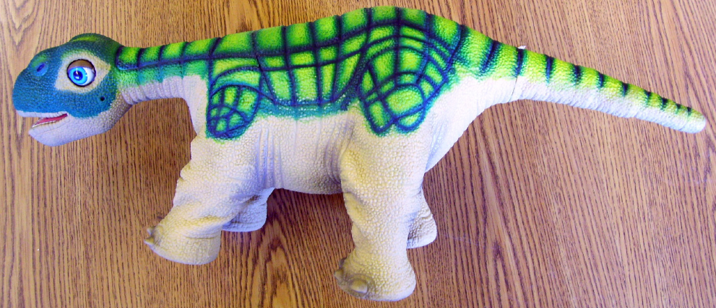  Pleo Dinosaur | 1
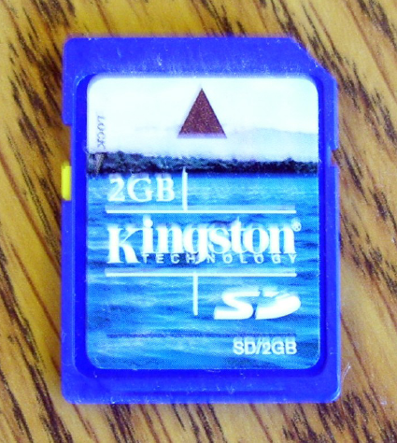  SD Card | 1
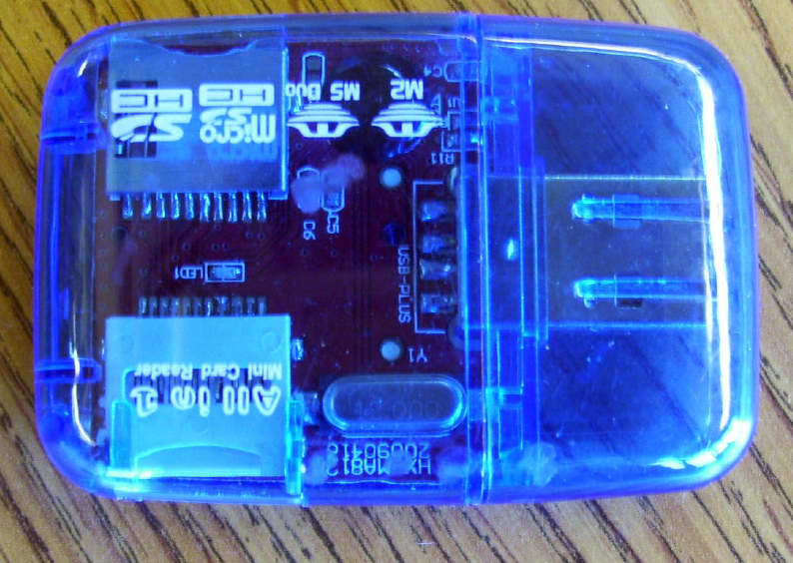  SD Reader | 1
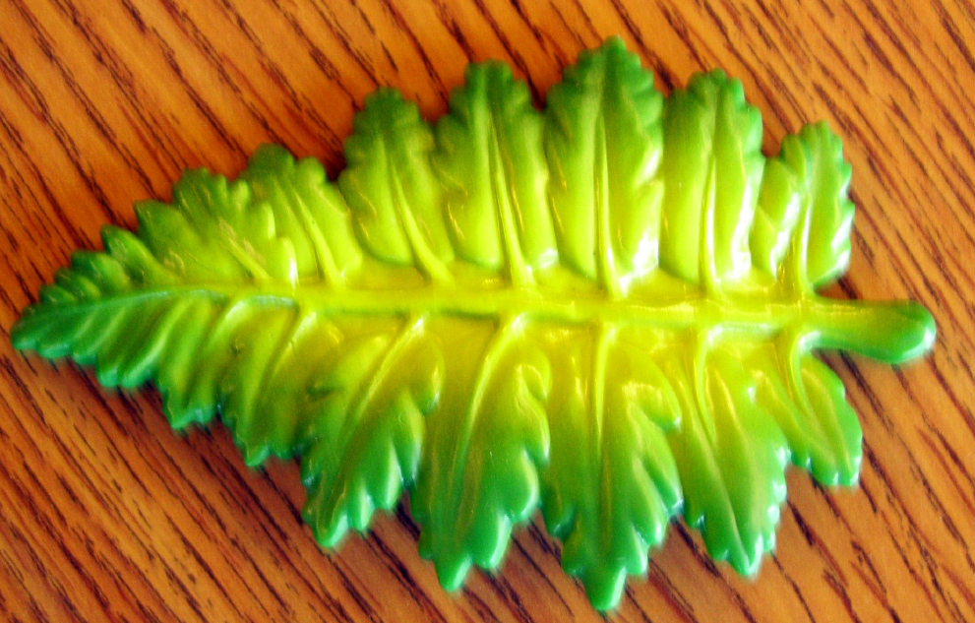  Dinosaur Leaf | 1
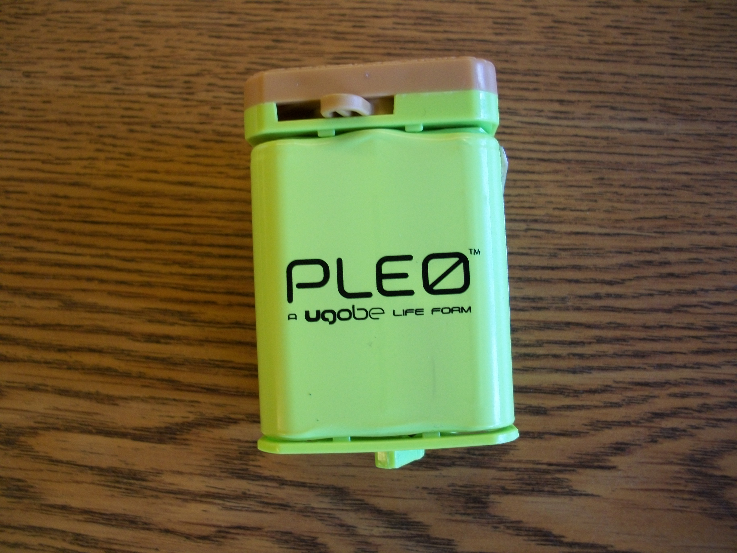  Pleo Batteries | 2  Should be charged. | Are the batteries charged? Y / N
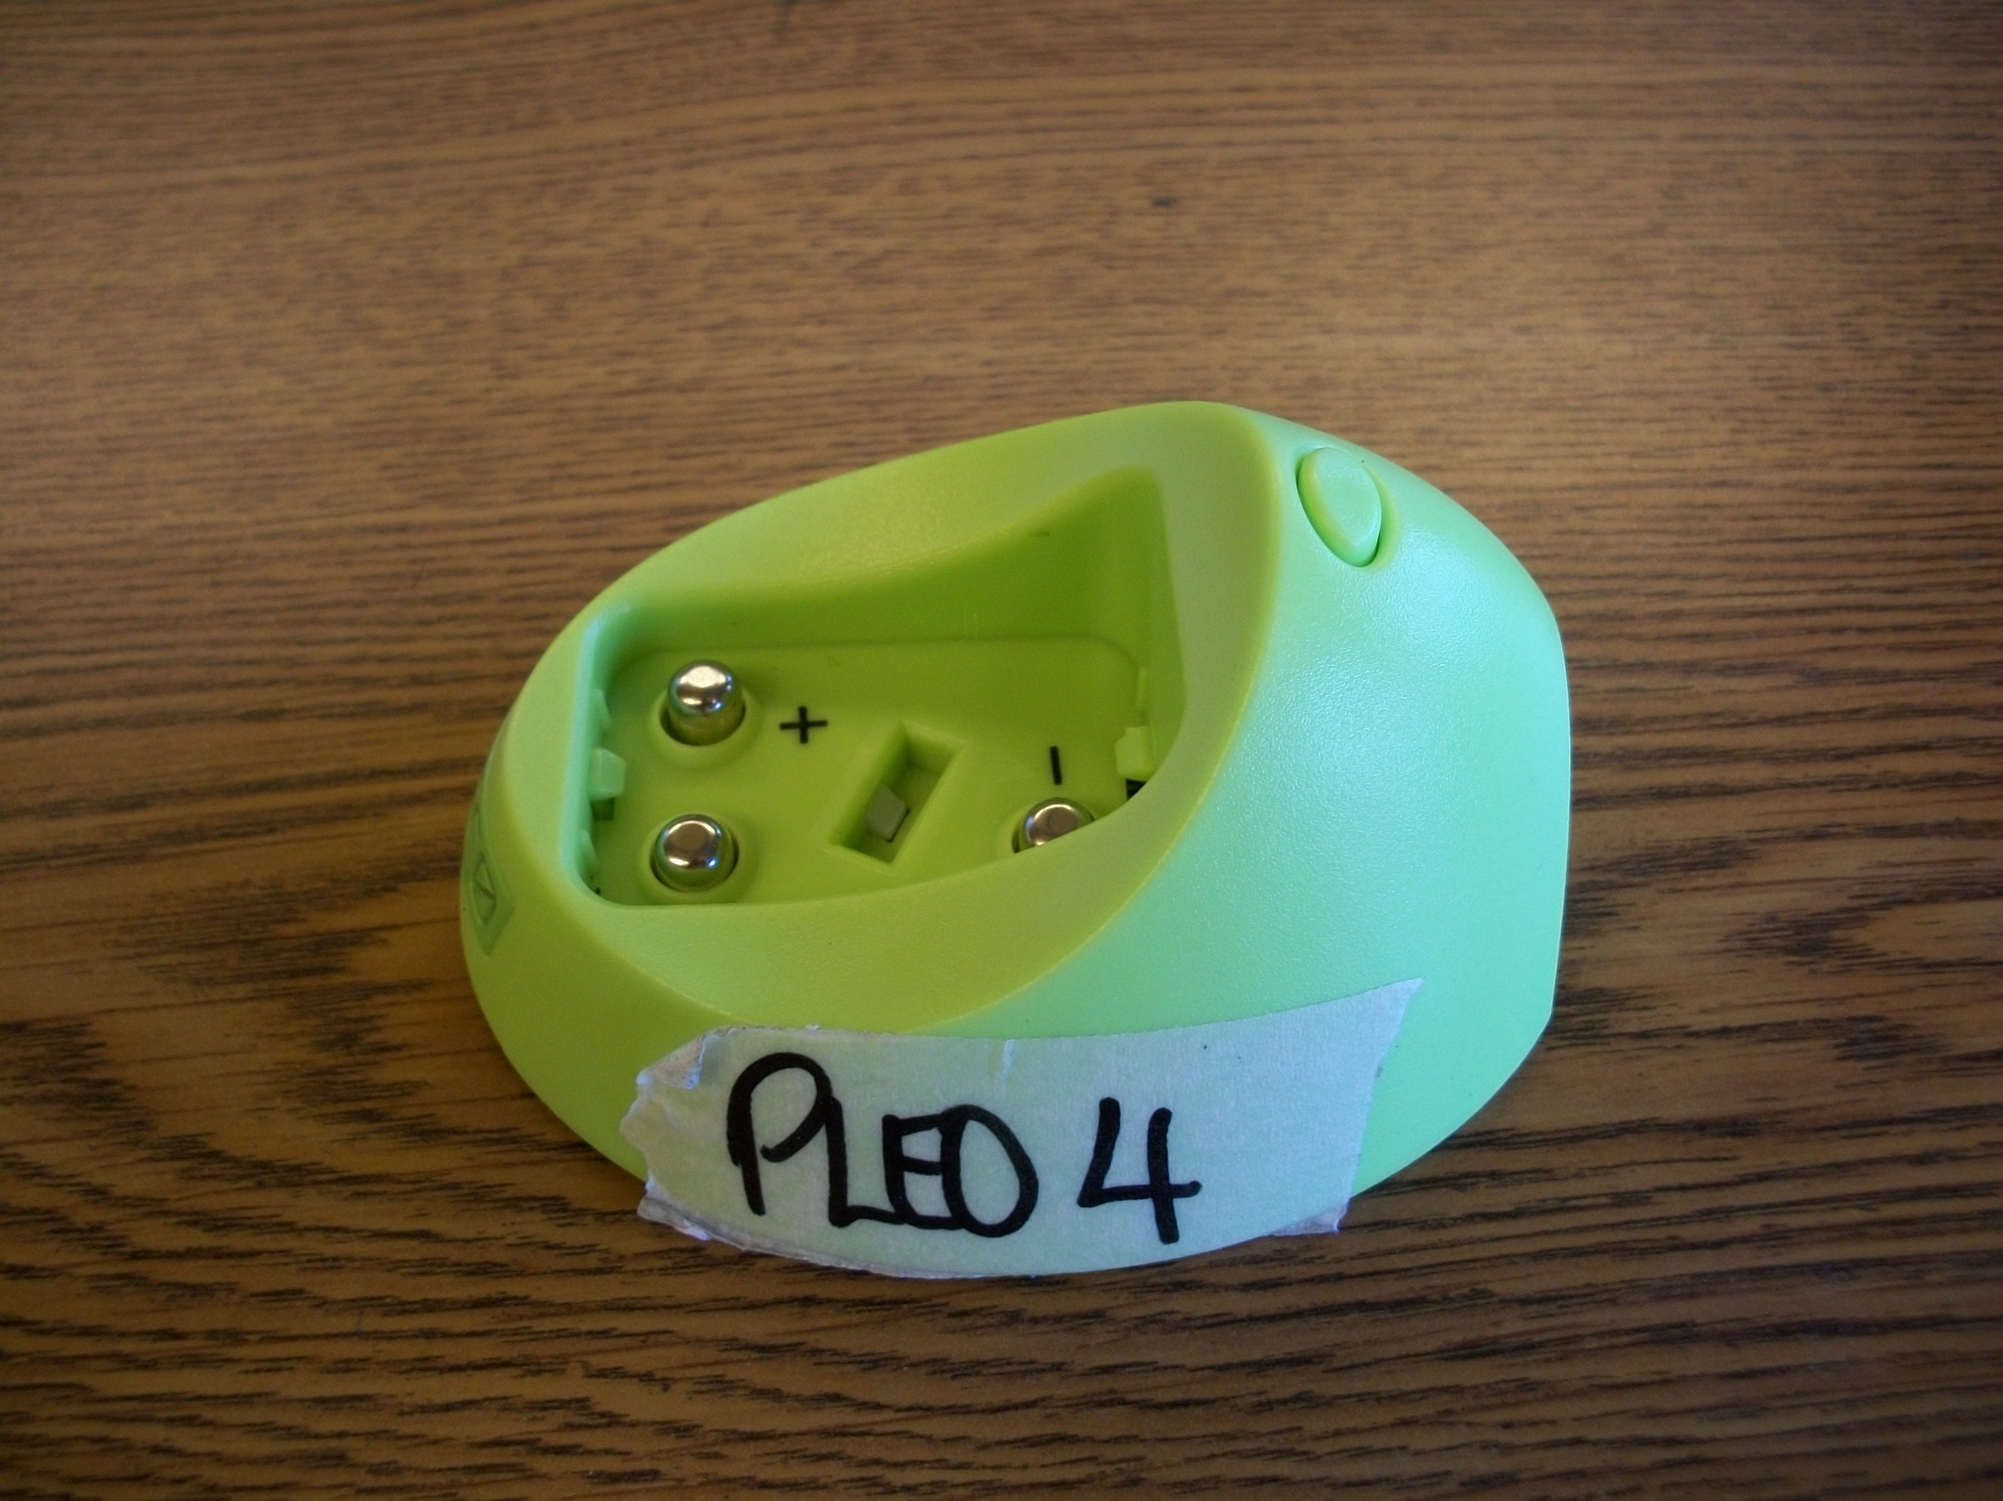  Battery Dock/Holder | 1
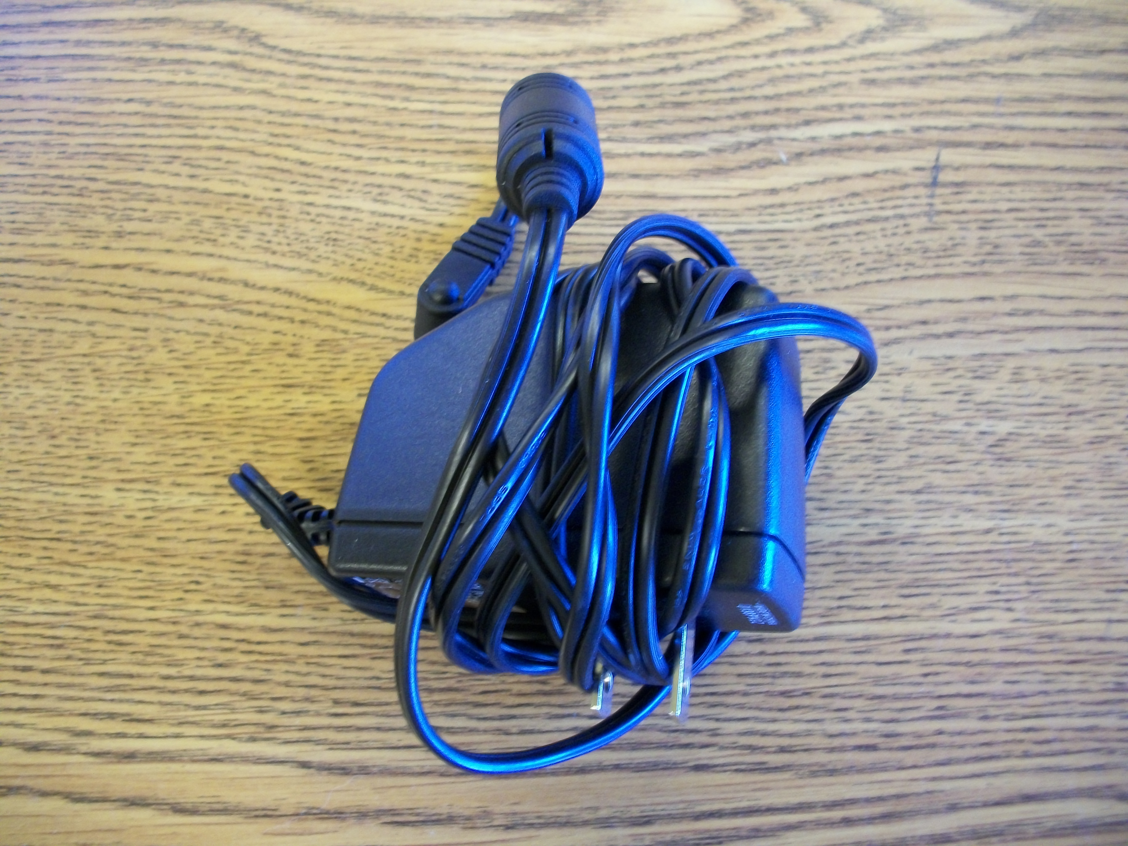  Battery Charger | 1

Name: ______________________________________

Organization: ______________________________________

Kit Number: ______________________________________

Date: ______________________________________

Notes/missing parts:
______________________________________
______________________________________
______________________________________
______________________________________
______________________________________
______________________________________

